SQL bank project

First main root map
RDSBANK_BANKS-- TO Maintain bank infromations
RSDBANK_PRODUCTS --- to maintain products of bank
RDSBANK_SUB_PRODUCTS -- details of products -silver/gold/platinum
RSDBANK_EMPLOYEES----to maintain bank employees data
RDSBANK_CUSTOMERS -- to maintain customers data of the bank
RDSBANK_CUS_TRANSACTIONS
RDSBANK_PASSWORD_TRACK

table name RSDbank_bank

bank _id bank_code bank_location is headoffice
1000 ttsbank001 Chennai y
1001 ttsbank002 Madurai n
1002 ttsabnk003 coimbature nz
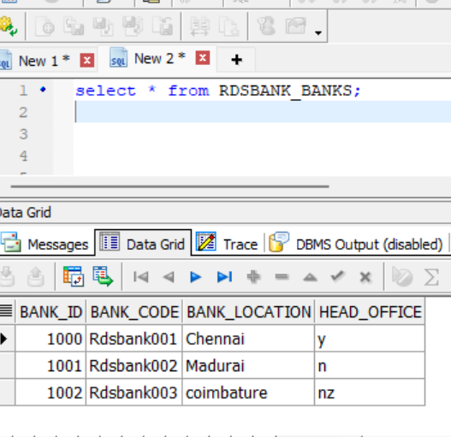

-=============================

Rds bank products
product_id product_name product_code
2000 savings sb
2001 current cb
2003 business bb

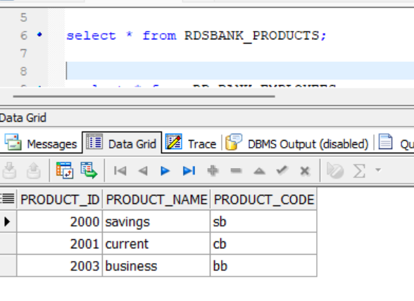
Rds banksub_product
sub_product_id product_id features balance_limit withdraw_limit
3000 2000 siver 5000 5000
3001 2000 gold 10000 100000
3002 2000 platinum 15000 2500000

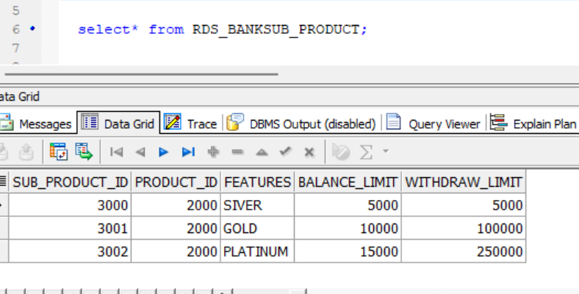
-==============================================

Rds bank employees

employee_id employee_name bank_id
4000 raj 1001
4001 vigram 1000
-=====================================
Rdsbank_customer

customer_id customer_name customer_phno customer_mail aadhar_phno pan_no password

5000 raja 94445566 1234
--------------------------------------------------
Rdsbank_cus_products
cus_product_id sub_product_id customer_id account_no account_open_on status avaliable_balance bank_id
6000 3000 5000 987654321 23-12-2025 active 5000 10

--------=====================

Rsdbank_cus_transaction

cus_trans_id cust_product_id trans_amount trans_type trans_on benef.acc trans_mode account_balance

7000 6000 5000 c 23-12-2025 self new customer 5000
7001 6000 3000 c 23-12-2025 gpay upi 8000

CREATE TABLE RDSBANK_CUSTOMER_TRANSACTIONS
(
cus_trans_id NUMBER PRIMARY KEY,
cust_product_id NUMBER NOT NULL,
trans_amount NUMBER(10,2) NOT NULL,
trans_type CHAR(1) CHECK (trans_type IN ('C','D')),
trans_on DATE NOT NULL,
benef_acc VARCHAR2(30),
trans_mode VARCHAR2(20),
account_balance NUMBER(10,2),

CONSTRAINT fk_cust_product
FOREIGN KEY (cust_product_id)
REFERENCES RSDBANK_PRODUCTS (product_id
-==================================================
Rsdbank_password_track

track_id customer_id customer_password password_change_on
8000 5000 12345 24-12-2025

RDSBANK_BANKS-- TO Maintain bank infromations
RSDBANK_PRODUCTS --- to maintain products of bank
RDSBANK_SUB_PRODUCTS -- details of products -silver/gold/platinum
RSDBANK_EMPLOYEES----to maintain bank employees data
RDSBANK_CUSTOMERS -- to maintain customers data of the bank
RDSBANK_CUS_TRANSACTIONS
RDSBANK_PASSWORD_TRACK
=--=-======================

RDSBANK_BANK -----
Create table RDSBANK_BANKS
(
Bank_id NUMBER,
bank_code varchar2(25),
bank_location varchar2(30),
head_office varchar2(30),

insert into RDSBANK_BANKS values(1000,'Rdsbank001','Chennai','y');
insrt into RDSBANK_BANKS values(1001,'Rdsbank002','Madurai','n');
insert into Rdsbank_banks values(1002,'Rdsbank003','coimbature','nz');

=----------------------------------------------------
RSDBANK_PRODUCTS --- to maintain products of bank

create table RSDBANK_PRODUCTS
(
product_id number primary key,
Product_name varchar2(20),
product_code varchar2(10)),
CONSTRAINT pk_rsdbank_products PRIMARY KEY (product_id));

insert into RSDBANK_PRODUCTS values(2000,'savings','sb');
insrt into RSDBANK_PRODUCTS values(2001,'current','cb');
insert into RSDBANK_PRODUCTS values(2003,'business','bb');

-------------------------------------------------------

RDSBANK_SUB_PRODUCTS --details of products -silver/gold/platinum
sub_product_id product_id features balance_limit withdraw_limit
3000 2000 siver 5000 5000
3001 2000 gold 10000 100000
3002

CREATE TABLE RDS_BANKSUB_PRODUCT
(
sub_product_id NUMBER(10) PRIMARY KEY,
product_id NUMBER(10),
features VARCHAR2(20),
balance_limit NUMBER(15),
withdraw_limit NUMBER(15)
);

insert into RDS_BANKSUB_PRODUCT values(3000,2000,'SIVER',5000,5000);
insrt into RDS_BANKSUB_PRODUCT values(3001,'GOLD',10000,1000000);
insert into RDS_BANKSUB_PRODUCT values(3002,'PLATINUM',15000,250000);

-=================================

RSDBANK_EMPLOYEES---

CREATE TABLE RDSBANK_EMPLOYEES
(
employee_id NUMBER(10) PRIMARY KEY,
employee_name VARCHAR2(50),
bank_id NUMBER(10)
);

insert into RDS_BANKSUB_PRODUCT values(4000,'Raj',10001);
insert into RDS_BANKSUB_PRODUCT values(4001,'vigram'1000)

--=-=---------------------------------
RDSBANK_CUSTOMERS -- to maintain customers data of the bank

CREATE TABLE RDSBANK_CUSTOMER
(
customer_id NUMBER PRIMARY KEY,
customer_name VARCHAR2(50)
customer_phno VARCHAR2(15) UNIQUE NOT NULL,
customer_mail VARCHAR2(50)
aadhar_phno VARCHAR2(12) UNIQUE NOT NULL,
pan_no VARCHAR2(10) UNIQUE NOT NULL,
password VARCHAR2(50));

INSERT INTO RDSBANK_CUSTOMER VALUES
(5000, 'raja', '9123456789', 'Raja@gmail.com', '234567890123', 'PQRSX5678K', 'raa@456');

-================================PR

Rsdbank_cus_transaction

cus_trans_id cust_product_id trans_amount trans_type trans_on benef.acc trans_mode account_balance

7000 6000 5000 c 23-12-2025 self new customer 5000
7001 6000 3000 c 23-12-2025 gpay upi 8000

Rsdbank_password_track

track_id customer_id customer_password password_change_on
8000 5000 12345 24-12-2025
-=---=---=--=-=PROCEDURE---==--========================= WAIT ING

CREATE OR REPLACE PROcedure RDS_bank_Products(P_bank_prod out sys_refcursor)as
begin

